Supplementary Table 1. Definition of parameters calibrated in the CBM-CFS3

|  |  |
| --- | --- |
| Parameter name | Definition |
| OtherToBranchSnagSplit | proportion of the litterfall from "other" pool (stumps, branches, and small trees including bark) that becomes snag branches |
| SS_fr | fall rate of the softwood and hardwood stem snags |
| BS_fr | fall rate of the softwood and hardwood branch snags |
| CoarseRootTurnProp | death rate of coarse roots |
| FineRootTurnProp | death rate of fine roots |
| CoarseRootAGSplit | fraction of dead coarse roots sent to the aboveground fast pool |
| FineRootAGSplit | fraction of dead fine roots sent to the aboveground very fast pool |
| AGVF_b | decay rate of aboveground very fast (AGVF; foliar litter and dead fine roots in the soil organic layer) pool when mean annual temperature is 10°C |
| BGVF_b | decay rate of belowground very fast (BGVF; dead fine roots in the mineral soil) pool when mean annual temperature is 10°C |
| AGF_b | decay rate of aboveground fast (AGF; small and fine woody debris) pool when mean annual temperature is 10°C |
| BGF_b | decay rate of belowground fast (BGF; dead coarse roots in the mineral soil) pool when mean annual temperature is 10°C |
| M_b | decay rate of medium (M; coarse woody debris) pool when mean annual temperature is 10°C |
| AGS_b | decay rate of aboveground slow (AGS; soil organic layer) pool when mean annual temperature is 10°C |
| BGS_b | decay rate of belowground slow (BGS: mineral soil organic matter) pool when mean annual temperature is 10°C |
| SWSS_b | decay rate of softwood stem snags (SWSS; softwood dead standing stemwood) pool when mean annual temperature is 10°C |
| SWBS_b | decay rate of softwood branch snag (SWBS; softwood dead standing branches of merchantable and non-merchantable sized trees, tops and stumps of merchantable sized trees and non-merchantable sized tree stemwood and bark) pool when mean annual temperature is 10°C |
| HWSS_b | decay rate of hardwood stem snags (HWSS; hardwood dead standing stemwood) pool when mean annual temperature is 10°C |
| HWBS_b | decay rate of hardwood branch snag (HWBS; hardwood dead standing branches of merchantable and non-merchantable sized trees, tops and stumps of merchantable sized trees and non-merchantable sized tree stemwood and bark) pool when mean annual temperature is 10°C |
| AGVF_q10 | temperature sensitivity of AGVF pool |
| BGVF_q10 | temperature sensitivity of BGVF pool |
| AGF_q10 | temperature sensitivity of AGF pool |
| BGF_q10 | temperature sensitivity of BGF pool |
| M_q10 | temperature sensitivity of M pool |
| AGS_q10 | temperature sensitivity of AGS pool |
| BGS_q10 | temperature sensitivity of BGS pool |
| SWSS_q10 | temperature sensitivity of SWSS |
| SWBS_q10 | temperature sensitivity of SWBS |
| HWSS_q10 | temperature sensitivity of HWSS |
| HWBS_q10 | temperature sensitivity of HWBS |
| AGVF_p | proportion of decayed AGVF pool lost to atmosphere |
| BGVF_p | proportion of decayed BGVF pool lost to atmosphere |
| AGF_p | proportion of decayed AGF pool lost to atmosphere |
| BGF_p | proportion of decayed BGF pool lost to atmosphere |
| M_p | proportion of decayed M pool lost to atmosphere |
| SWSS_p | proportion of decayed SWSS pool lost to atmosphere |
| SWBS_p | proportion of decayed SWBS pool lost to atmosphere |
| HWSS_p | proportion of decayed HWSS pool lost to atmosphere |
| HWBS_p | |  | | --- | | proportion of decayed HWBS pool lost to atmosphere | |
| rb_sw_a | parameter in the equation , which determines root biomass in softwood trees $rb_{sw}={rb}_{}×AB_{sw}$ $rb_{hw}={rb}_{}×{{AB}_{sw}}^{{rb}_{}}$ |
| rb_hw_a | parameters in the equation , which determine root biomass in hardwood trees |
| rb_hw_b |
| frp_a | parameters in the equation $P_{fr}=frp_{a}+frp_{b}×e^{frp_{c}×rb},$ which determine the fraction of fine root |
| frp_b |
| frp_c |
| SlowMixingRate | rate of C transfer from AGS to BGS |
|  |  |

Supplementary Table 2. Prior and posterior estimates of the parameters regulating deadwood and soil C dynamics in CBM-CFS3

|  |  |  |  |  |  |  |  |  |  |  |  |
| --- | --- | --- | --- | --- | --- | --- | --- | --- | --- | --- | --- |
| name | prior | | |  | | posterior | | | | | |
| value | minimum | maximum |  | | mean | | lower 95 % CI | | upper 95 % CI | |
| OtherToBranchSnagSplit | 0.250 | 0.125 | 0.375 | | 0.353 | | 0.320 | | 0.373 | |  |
| SS_fr | 0.032 | 0.008 | 0.200 | | 0.066 | | 0.052 | | 0.082 | |  |
| BS_fr | 0.100 | 0.074 | 0.375 | | 0.081 | | 0.075 | | 0.093 | |  |
| CoarseRootTurnProp | 0.020 | 0.010 | 0.030 | | 0.019 | | 0.011 | | 0.028 | |  |
| FineRootTurnProp | 0.641 | 0.320 | 0.960 | | 0.864 | | 0.707 | | 0.951 | |  |
| CoarseRootAGSplit | 0.500 | 0.250 | 0.750 | | 0.523 | | 0.295 | | 0.720 | |  |
| FineRootAGSplit | 0.500 | 0.250 | 0.750 | | 0.663 | | 0.530 | | 0.742 | |  |
| AGVF_b | 0.355 | 0.284 | 0.426 | | 0.345 | | 0.290 | | 0.409 | |  |
| BGVF_b | 0.500 | 0.160 | 0.560 | | 0.349 | | 0.187 | | 0.524 | |  |
| AGF_b | 0.144 | 0.010 | 0.270 | | 0.225 | | 0.194 | | 0.259 | |  |
| BGF_b | 0.144 | 0.045 | 0.410 | | 0.230 | | 0.072 | | 0.382 | |  |
| M_b | 0.037 | 0.007 | 0.110 | | 0.064 | | 0.045 | | 0.092 | |  |
| AGS_b | 0.015 | 0.002 | 0.030 | | 0.022 | | 0.013 | | 0.029 | |  |
| BGS_b | 0.003 | 0.002 | 0.005 | | 0.004 | | 0.004 | | 0.005 | |  |
| SWSS_b | 0.019 | 0.005 | 0.078 | | 0.014 | | 0.006 | | 0.030 | |  |
| SWBS_b | 0.072 | 0.036 | 0.110 | | 0.047 | | 0.037 | | 0.064 | |  |
| HWSS_b | 0.019 | 0.005 | 0.078 | | 0.054 | | 0.027 | | 0.075 | |  |
| HWBS_b | 0.072 | 0.036 | 0.110 | | 0.073 | | 0.042 | | 0.103 | |  |
| AGVF_q10 | 2.650 | 1.000 | 3.000 | | 2.415 | | 1.535 | | 2.947 | |  |
| BGVF_q10 | 2.000 | 1.000 | 3.000 | | 2.031 | | 1.161 | | 2.873 | |  |
| AGF_q10 | 2.000 | 1.000 | 3.000 | | 1.154 | | 1.017 | | 1.346 | |  |
| BGF_q10 | 2.000 | 1.000 | 3.000 | | 2.029 | | 1.167 | | 2.853 | |  |
| M_q10 | 2.000 | 1.000 | 3.000 | | 1.534 | | 1.064 | | 2.244 | |  |
| AGS_q10 | 2.650 | 1.000 | 3.000 | | 2.140 | | 1.319 | | 2.858 | |  |
| BGS_q10 | 1.000 | 1.000 | 3.000 | | 1.231 | | 1.021 | | 1.578 | |  |
| SWSS_q10 | 2.000 | 1.000 | 3.000 | | 2.060 | | 1.174 | | 2.866 | |  |
| SWBS_q10 | 2.000 | 1.000 | 3.000 | | 2.309 | | 1.419 | | 2.925 | |  |
| HWSS_q10 | 2.000 | 1.000 | 3.000 | | 1.830 | | 1.087 | | 2.803 | |  |
| HWBS_q10 | 2.000 | 1.000 | 3.000 | | 2.004 | | 1.160 | | 2.841 | |  |
| AGVF_p | 0.815 | 0.720 | 0.889 | | 0.789 | | 0.729 | | 0.860 | |  |
| BGVF_p | 0.830 | 0.445 | 1.000 | | 0.669 | | 0.496 | | 0.851 | |  |
| AGF_p | 0.830 | 0.650 | 1.000 | | 0.869 | | 0.711 | | 0.984 | |  |
| BGF_p | 0.830 | 0.700 | 0.900 | | 0.817 | | 0.725 | | 0.890 | |  |
| M_p | 0.830 | 0.700 | 0.900 | | 0.793 | | 0.713 | | 0.881 | |  |
| SWSS_p | 0.830 | 0.100 | 1.000 | | 0.515 | | 0.155 | | 0.919 | |  |
| SWBS_p | 0.830 | 0.100 | 1.000 | | 0.511 | | 0.153 | | 0.914 | |  |
| HWSS_p | 0.830 | 0.100 | 1.000 | | 0.667 | | 0.243 | | 0.966 | |  |
| HWBS_p | 0.830 | 0.100 | 1.000 | | 0.651 | | 0.231 | | 0.964 | |  |
| rb_hw_a | 1.576 | 1.309 | 1.843 | | 1.569 | | 1.346 | | 1.797 | |  |
| rb_sw_a | 0.222 | 0.218 | 0.226 | | 0.222 | | 0.219 | | 0.225 | |  |
| rb_hw_b | 0.615 | 0.580 | 0.650 | | 0.612 | | 0.584 | | 0.644 | |  |
| frp_a | 0.072 | 0.049 | 0.095 | | 0.067 | | 0.051 | | 0.088 | |  |
| frp_b | 0.354 | 0.291 | 0.417 | | 0.384 | | 0.332 | | 0.414 | |  |
| frp_c | -0.060 | -0.090 | -0.040 | | -0.055 | | -0.073 | | -0.042 | |  |
| SlowMixingRate | 0.006 | 0.003 | 0.009 | | 0.004 | | 0.003 | | 0.006 | |  |

Supplementary Fig. 1. Changes in model performance [RMSE (a), and per cent of explained spatial variability (b)] evaluated for calibration (*n* = 326) and validation (*n* = 309) data groups.

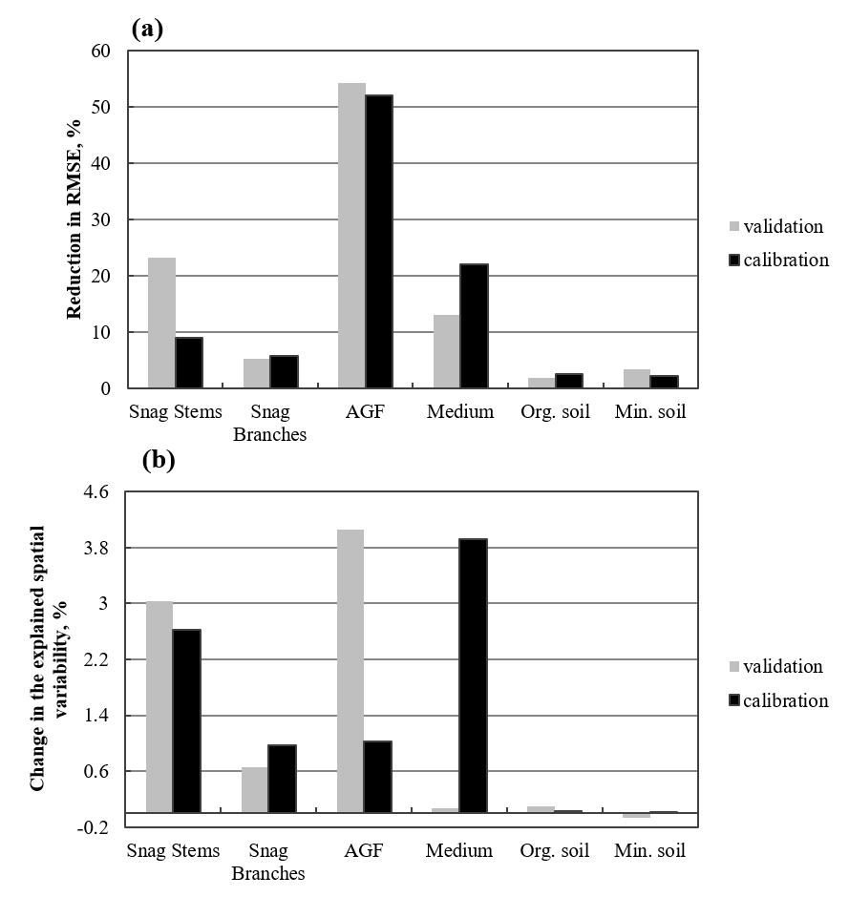

Supplementary Fig. 2. Reconstruction of Fig. 3 in Li et al. (2003) with estimated parameters for softwoods (SW) and hardwoods (HW). The fitted equation was $P_{f}={frp}_{a}+{frp}_{b}×e^{{frp}_{c}×RB}$, where $P_{f}$ is the proportion of fine roots, $RB$ is total root biomass and the rest are parameters. The fitting method used the Bayesian Markov Chain Monte Carlo technique as described in the Methods section 2.2. frp_a, frp_b, and frp_c were 0.07 (±0.01 SD), 0.313 (±0.05 SD), and -0.074 (±0.015 SD) respectively for softwoods, and 0.073 (±0.016 SD), 0.316 (±0.01 SD), and -0.029 (±0.012 SD) respectively for hardwoods.

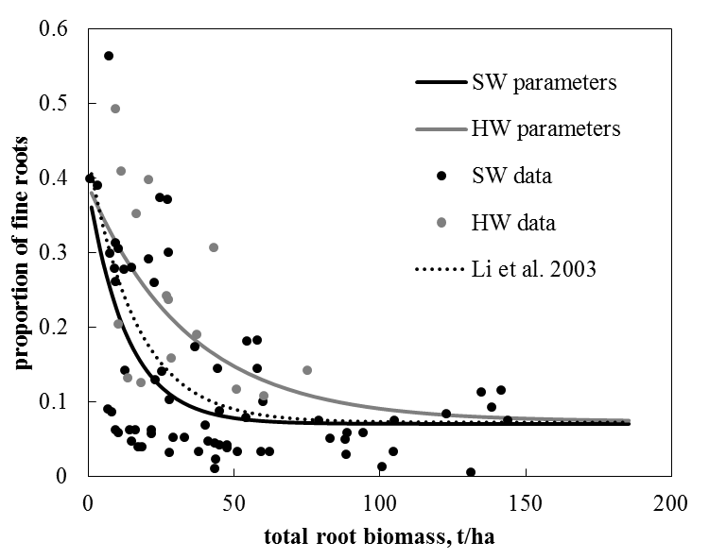

Supplementary Fig. 3. Effect of temperature seasonality on organic matter decay rates. We calculated annual decay rates (k) using mean annual temperature [k(MAT)], and by averaging k’s calculated for each month using mean monthly temperatures (mean k). Calculating the decay rates using monthly temperatures substantially differed from the decay rates calculated with MAT in fast-cycling pools (a). The difference between the decay rates calculated with MAT and monthly temperatures was strongly correlated with temperature seasonality (b).

